Metadata

Meta Title
How to Replace Your Wiper Blades | The Official Mopar eStore

Meta Description
Discover how to replace windshield wiper blades with this step-by-step guide. Shop genuine Mopar wiper blades or schedule installation service.

Keywords
- “wiper blades” = 27,100 monthly SV
- “how to replace wiper blades” = 22,200 monthly SV
- “windshield wiper blades” = 60,500 monthly SV
- “change wiper blades” = 18,100 monthly SV

URL Structure
/guides/how-to/change-wiper-blades

H1 Header
Wiper Blade Replacement

Header Banner
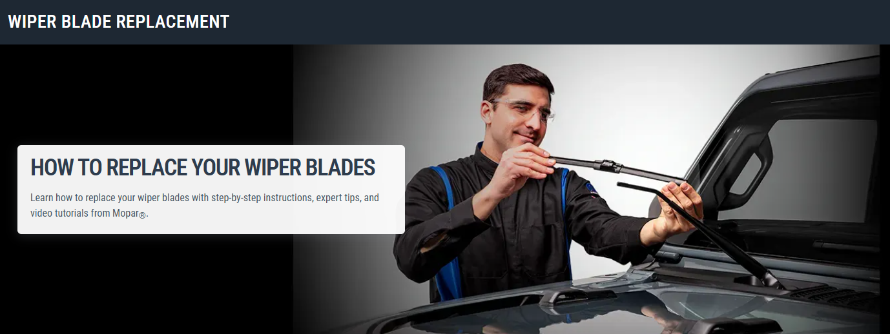
H3 Header:
How to Replace Your Wiper Blades

Banner Copy:
Learn how to replace your wiper blades with step-by-step instructions, expert tips, and video tutorials from Mopar®.

H3: VIDEO: WIPER BLADE INSTALLATION GUIDE (video block)
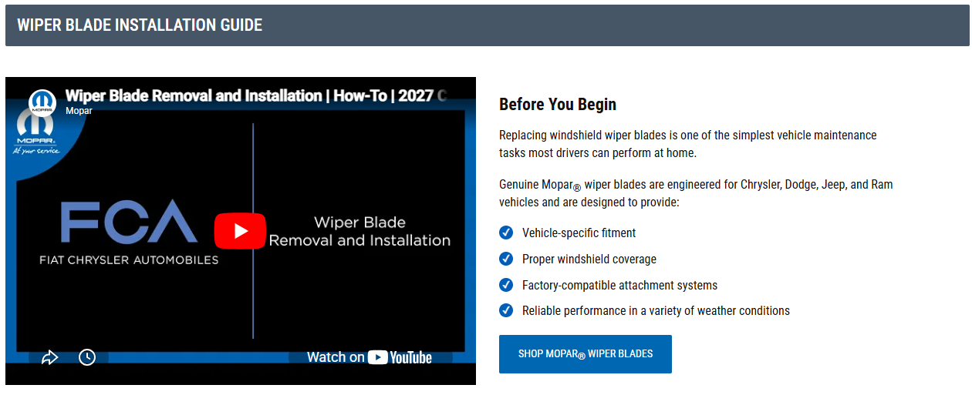

H4: Before you begin
Replacing windshield wiper blades is one of the simplest vehicle maintenance tasks most drivers can perform at home.
Genuine Mopar wiper blades are engineered for Chrysler, Dodge, Jeep, and Ram vehicles and are designed to provide:
- Vehicle-specific fitment
- Proper windshield coverage
- Factory-compatible attachment systems
- Reliable performance in a variety of weather conditions
[ CTA Button: Shop Mopar Wiper Blades ]

H3: Tools you’ll need
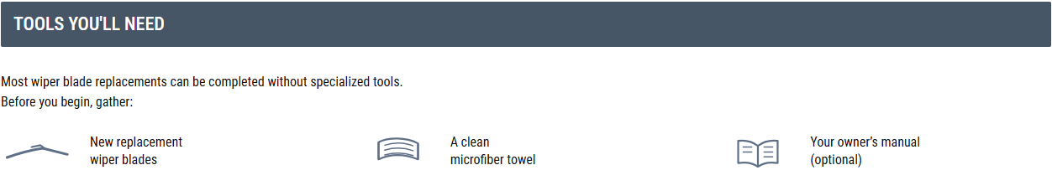
Most wiper blade replacements can be completed without specialized tools.
Before you begin, gather:
- New replacement wiper blades
- A clean microfiber towel
- Your owner's manual (optional)

H3: How to replace wiper blades, step-by-step
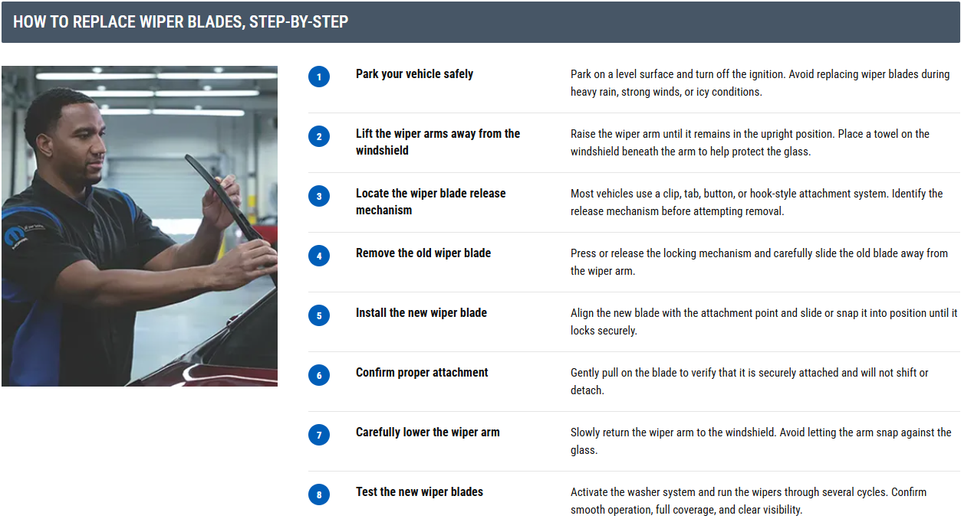

H4: Step 1: Park your vehicle safely
Park your vehicle on a level surface and turn off the ignition.
If you're working outdoors, avoid replacing wiper blades during heavy rain, strong winds, or icy conditions.

H4: Step 2: Lift the wiper arms away from the windshield
Carefully raise the wiper arm away from the windshield until it remains in the upright position.
Because wiper arms are spring-loaded, place a towel on the windshield beneath the arm to help protect the glass while you work.

H4: Step 3: Locate the wiper blade release mechanism
Most vehicles use a clip, tab, button, or hook-style attachment system to secure the blade to the wiper arm. Inspect the connection point and identify the release mechanism before attempting removal.
If you're unsure of your vehicle's attachment style, consult your owner's manual.

H4: Step 4: Remove the old wiper blade
Press or release the locking mechanism and carefully slide the old blade away from the wiper arm.
Avoid forcing the blade if it does not immediately detach. Excessive force may damage the attachment point or wiper arm.

H4: Step 5: Install the new wiper blade
Align the new wiper blade with the attachment point on the wiper arm.
Slide or snap the blade into position according to the connector design until it locks securely into place.
Most installations will produce an audible click or noticeable locking sensation.

H4: Step 6: Confirm proper attachment
Before lowering the arm, gently pull on the blade to verify that it is securely attached. The blade should remain firmly connected without shifting or detaching.

H4: Step 7: Carefully lower the wiper arm
Slowly return the wiper arm to the windshield. Avoid allowing the bare arm to snap against the glass, as this may crack or chip the windshield.

H4: Step 8: Test the new wiper blades
Activate the washer system and run the wipers through several cycles. Confirm smooth operation, full coverage, and clear visibility.

H3: Common wiper blade replacement mistakes
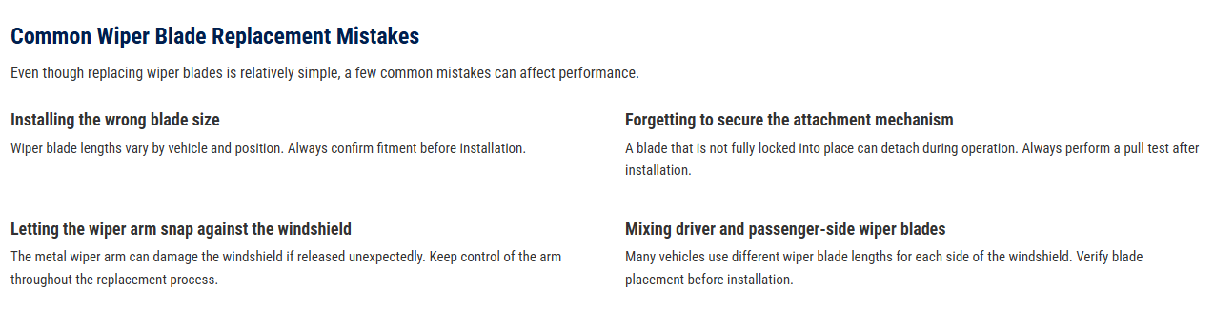
Even though replacing wiper blades is relatively simple, a few common mistakes can affect performance.

H4: Installing the wrong blade size
Wiper blade lengths vary by vehicle and position. Always confirm fitment before installation.

H4: Forgetting to secure the attachment mechanism
A blade that is not fully locked into place can detach during operation. Always perform a pull test after installation.

H4: Letting the wiper arm snap against the windshield
The metal wiper arm can damage the windshield if released unexpectedly. Keep control of the arm throughout the replacement process.

H4: Mixing driver and passenger-side wiper blades
Many vehicles use different wiper blade lengths for each side of the windshield. Verify blade placement before installation.

H3: Troubleshooting after installation
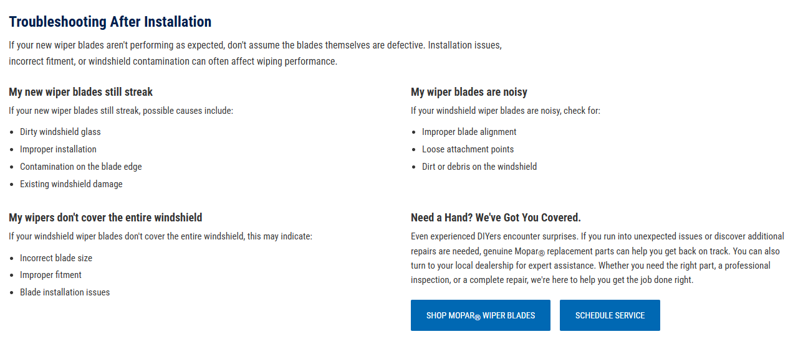
If your new wiper blades aren't performing as expected, don't assume the blades themselves are defective. Installation issues, incorrect fitment, or windshield contamination can often affect wiping performance.

H4: My new wiper blades still streak
If your new wiper blades still streak, possible causes include:
- Dirty windshield glass
- Improper installation
- Contamination on the blade edge
- Existing windshield damage

H4: My wiper blades are noisy
If your windshield wiper blades are noisy, check for:
- Improper blade alignment
- Loose attachment points
- Dirt or debris on the windshield

H4: My wipers don't cover the entire windshield
If your windshield wiper blades don’t cover the entire windshield, this may indicate:
- Incorrect blade size
- Improper fitment
- Blade installation issues

H4: Need a hand? We’ve got you covered. (Templated CTA section)
Even experienced DIYers encounter surprises. If you run into unexpected issues or discover additional repairs are needed, genuine Mopar® replacement parts can help you get back on track. You can also turn to your local dealership for expert assistance. Whether you need the right part, a professional inspection, or a complete repair, we're here to help you get the job done right.
[ CTA Button: Shop Mopar Wiper Blades ]
[ CTA Button: Schedule Service ]

H3: Frequently Asked Questions (FAQs)
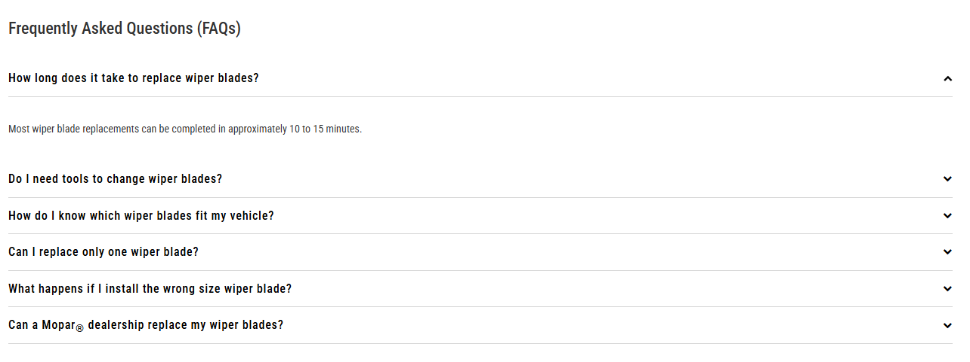

H4: How long does it take to replace wiper blades?
Most wiper blade replacements can be completed in approximately 10 to 15 minutes.

H4: Do I need tools to change wiper blades?
Most Mopar vehicles do not require specialized tools for wiper blade replacement.

H4: How do I know which wiper blades fit my vehicle?
You can use your VIN, owner's manual, or our Mopar parts lookup tool to identify the correct replacement blades.

H4: Can I replace only one wiper blade?
Although it is possible, replacing both blades at the same time helps ensure consistent windshield performance.

H4: What happens if I install the wrong size wiper blade?
Incorrect wiper blade sizes may reduce windshield coverage, create noise, or interfere with proper operation.

H4: Can a Mopar dealership replace my wiper blades?
Yes. Your local Mopar dealership can help identify the correct replacement wiper blades and perform professional installation.

H3: DIY Maintenance ARTICLES (Related Links block)
